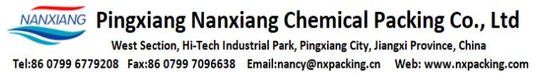**TIANJIN LONGFORD METAL PRODUCTS CO. , LTD**

NAMAJI, INDUSTRIAL PARK, DAZHANGZHUANG TOWN, BEICHEN DISTRICT, TIANJIN, CHINA

**CERTIFICATE OF QUALITY and QUANTITY**

Dated: Mar 15, 2024 Invoice No.: NXPIW24030503

Buyer: **HANAM INVESTMENT JSC**

Address: No. 7, Alley 36, Lane 296, Minh Khai Street, Mai Dong Ward, Hoang Mai District, Hanoi City Vietnam

We hereby certify that the products listed below meet the specified requirements:

|  |  |  |  |  |
| --- | --- | --- | --- | --- |
| **No.** | **Descriptions** | **Unit** | **Quantity** | **QC test** |
| 1 | Lamella  (Sheet Shape, unassebled)  Size: 1000*1000mm  Thickness: 0.5mm  Angle : 60oC  Dia of tube: 35mm  Material: PP | PCS | 400 | PASSED |
| 2 | Filter Nozzle  Flow: 0.5T/H  Dia: 24mm  Length: 116mm  Material: PP | PCS | 5000 | PASSED |
| 3 | Filter Nozzle  Flow: 1T/H  Dia: 32mm  Length: 125mm  Material: PP | PCS | 5000 | PASSED |

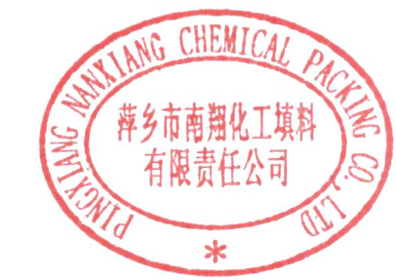 We hereby certify that the goods are made of best material, with first class workmanship, brand new, unused and correspond in all respects with the quality, quantity, specifications and performance in purchase order Remarks: No duplicate will be accepted.